I completed the task in the following steps:

**1. Implement Services for Managing Country**

* I have created a CountryService class in the *com.cognizant.ormlearn.service* package.
* Annotated the class with *@Service* to make it a Spring-managed service.
* Injected CountryRepository using *@Autowired.*
* This service acts as the business logic layer for all operations related to the Country entity.

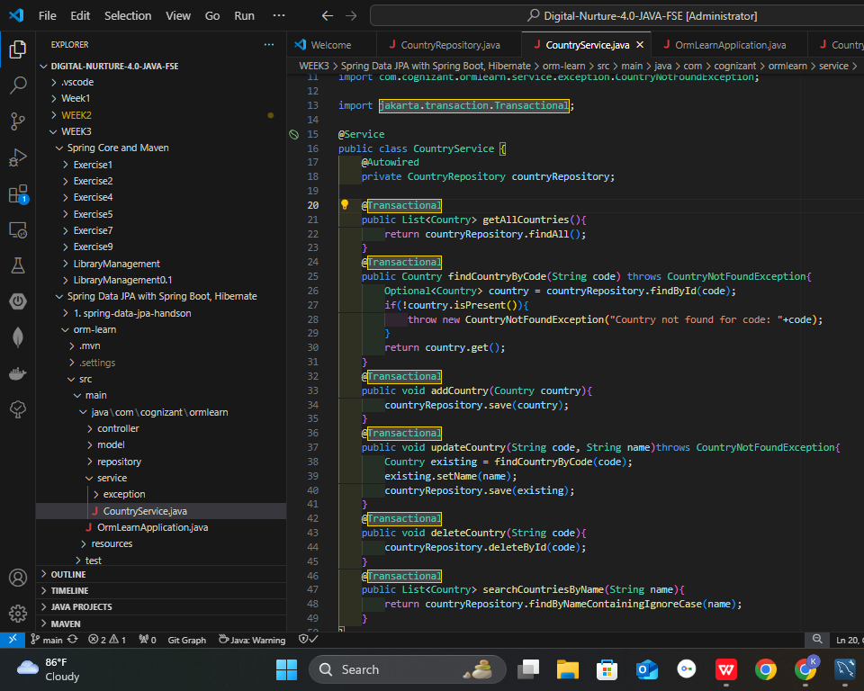

**2. Find a Country Based on Country Code**

* Inside CountryService, you implemented the method *findCountryByCode(String code)*.
* The method is annotated with *@Transactional* so that Spring manages the database session and transaction.
* I used the repository’s *findById(code)* method to look up the country.
* If no country is found, a custom exception *CountryNotFoundException* is thrown.
* This method is tested inside the main class by calling it with a sample code like *"IN"* and logging the output.

## **3. Add a New Country**

* In the same CountryService class, you added a method called *addCountry(Country country)*.
* Also marked this method with @Transactional.
* I used *countryRepository.save()* to persist a new country object to the database.
* This method is tested in the main class by:  
  + Creating a new Country instance with a unique code and name.
  + Calling addCountry() to save it.
  + Then calling findCountryByCode() again to verify the insertion.

**4.Output:**

**Ss1:** *get all countries*

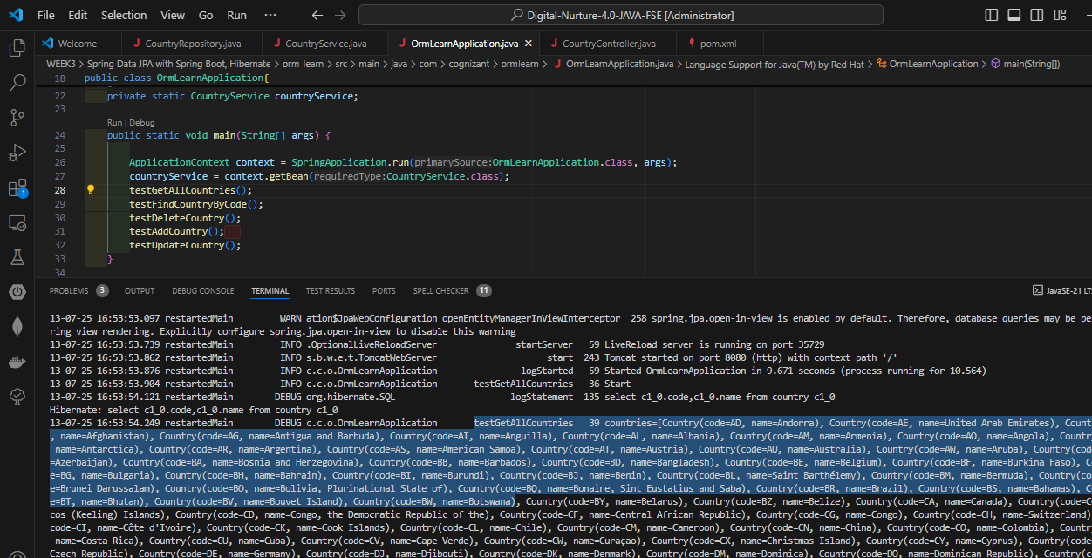

**4.Output:**

**Ss2:** *Finding country by code*

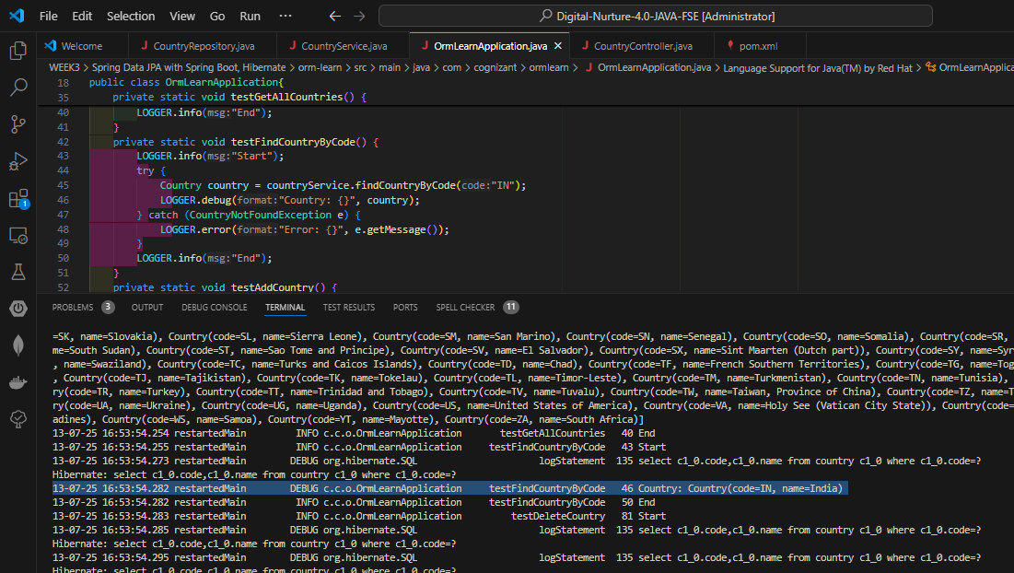

**Ss3:** *Deleting a certain country by its code*

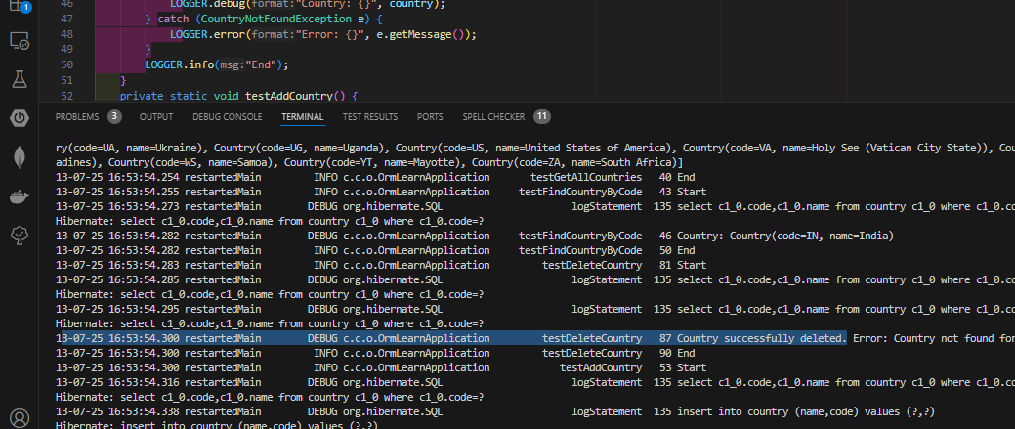

**4.Output:**

**Ss4:** *Creating the country which have been deleted previously.*

